231047020

SRUSTI D R

**JWTD Assignment-06(29/02/2024)**

**Json file example:**

Java project -> built path-> configure path ->library->module path -> **json-simple 1.1.1.jar**(add jar )

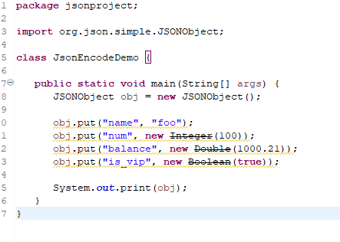

Output:



**Maven project:**

File->other->maven project->filter(org.apchetype.j2ee-sample)->Group id(com.maven)->Artifact id(maven)->finish

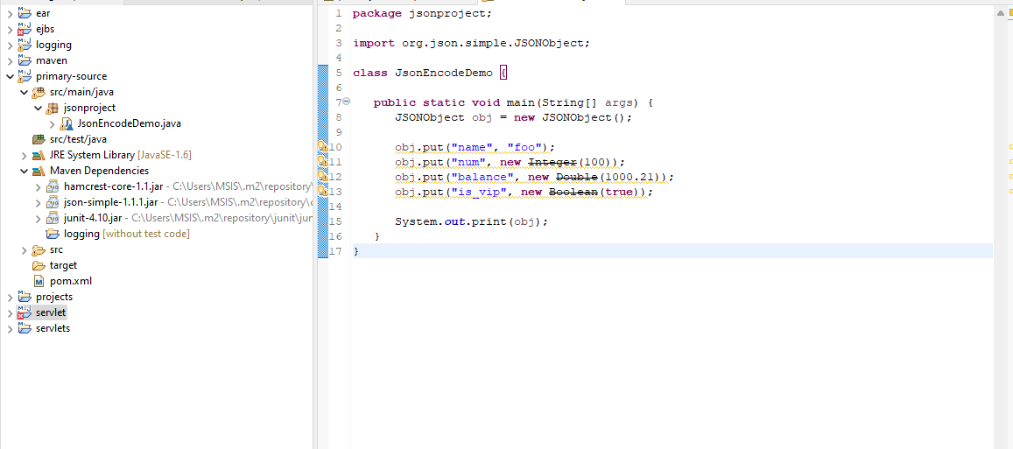

**Add dependency:**

From website**:** [Maven Repository: com.googlecode.json-simple » json-simple » 1.1.1 (mvnrepository.com)](https://mvnrepository.com/artifact/com.googlecode.json-simple/json-simple/1.1.1)

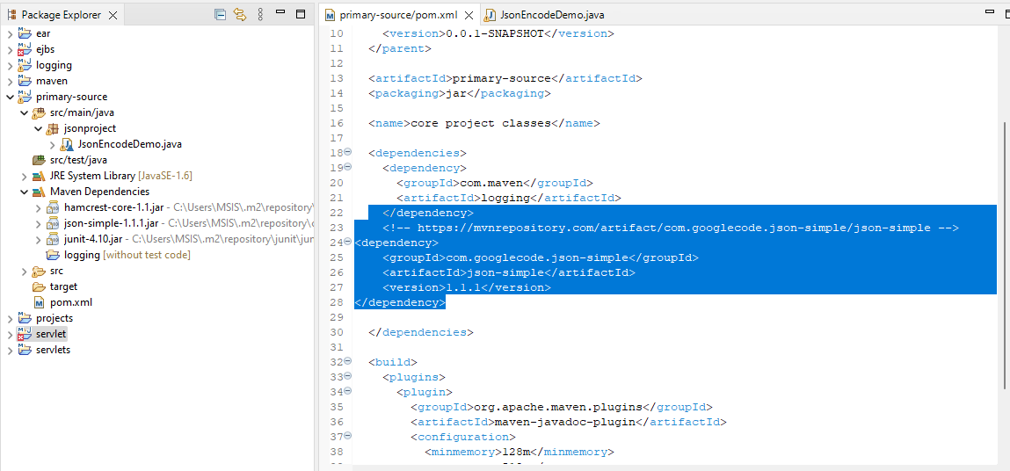

**Output:**

